 | HELLENIC TAEKWON-DO  PREVEZA HELLAS  Dimitriou Krokou 39, 48100 Preveza, Greece  Phone: +30 6980 067844 - +30 6983 517942  E-mail: efkleasitf@yahoo.gr | 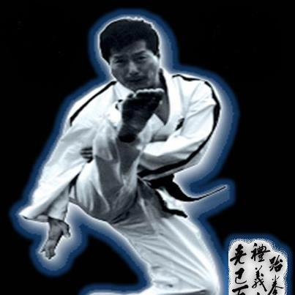

Open Taekwon-Do Seminar & Tournament Choi Jung Hwa 2013

For young juniors, juniors, adults, and seniors
26-28 th April, 2013

Dear friends,
I have the great honour to invite you to the Taekwon-Do Seminar and Open Tournament with the President Grand Master Choi Jung Hwa which will take place in our beautiful city of Preveza, by the Greek Ionian Sea. We strongly believe that practising under the guidance of the son of Taekwon-Do's founder will only be beneficial for us that Taekwon-Do is a way of living. Let's all come together and discover new aspects of Taekwon-Do by practising and interacting with the greatest living Grand Master of Taekwon-Do, President Choi Jung Hwa. For the closing of the event we are organizing an Open Tournament, dedicated to the President Grand Master Choi Jung Hwa, for those that wish to compete and gain valuable experience from it.We wish you to enjoy our event.

Your welcome!
Master Aggelos Soldatos, VII

I N V I T A T I O N

Place Sporthall Preveza, Sirako
Organizer Hellenic Association Taekwon-do Efkleas, Preveza 48100 Greece
Entries deadline 20th April 2013

Seminar 26th April 2013 : 17:00 - 20:00
27th April 2013 : 11:00 – 13:30 17:00 – 19:30

Referees Each country can send referees for the open and this will be the only status beeing. The organizer will provide lunch and stay for all referees for the contest day.
Coaches Coaches have to wear training suit and indoor gymnastic shoes. They have to consider every instruction that was given to them from organizer.
Rules The official protest note must be writtem in five minutes after sparring and get to president of Jury after paying amount of 25 EUR to organizers official. (Official I.T.F. Rules)
Draft Draft will be performed on April 22, 2013. The draw of athletes categories will take place in Conference Room at Margarona Royal Hotel.
Weigh checking On the day of tournament.
Each participant overweighing division limit will be transferred to higher division.
Prizes Medals will be awarded for 1st, 2nd and 2 x 3rd places individual.
Special awards for 3 best clubs and 2 best competitors.

Sparring Young Juniors up to 14 years old
Male: -25 kg, -30 kg, -35 kg. -40 kg, -45 kg, -50 kg, -55 kg, +55 kg
Female: -25 kg, -30 kg, -35 kg, -40 kg, -45 kg, -50 kg, +50 kg

Juniors up to 18 years old
Male: -50 kg, -55 kg, -60 kg, -65 kg, -70 kg.+70 kg
Female: -45 kg, -50 kg, -55 kg, -60 kg, -65 kg,+65 kg

Adults /above 18 years old
Male: -58 kg, -64 kg, -70 kg, -76 kg, -82 kg,+82 kg
Female: -50 kg, -55 kg, -60 kg, -65 kg, -70 kg,+70 kg

Seniors/ 36 and over
Male: -58 kg, -64 kg, -70 kg, -76 kg, -82 kg,+82 kg
Female: -50 kg, -55 kg, -60 kg, -65 kg, -70 kg,+70 kg

Hosinsul team 5+1 competitor
Sparring duration: 2 x 2 minutes qualifications

Patterns Yellow Belts from Chon - Ji to Dan Gun
Green Belts from Chon - Ji to Won Hyo
Blue Belts from Chon - Ji to Joon Gun
Red Belts from Chon - Ji to Hwa Rang
Black Belts 1st DAN from Chon - Ji to Choong Moo
Black Belts 2nd DAN and above from Chon - Ji to Ko Gae Baek

Qualifications: Second Tull on competitors choice
Finals: Second Tull on competitors choice

Schedule of events 08.00 – 09.00 Weigh-in
09.00 – 09.30 Referees and coaches meeting
09.30 – 10.00 Opening ceremonial
10.00 Competition
After the tournament will be the closing ceremony with special awards by the Mayor of Preveza City.

Contact address Mr. Stathis Kavadias, Secretary – Mr. Kostas Trivlis, Information
Mob. +30 6937 369299, +30 6983 517942
e-mail: efkleasitf@yahoo.gr

How to arrive to Preveza City?
Preveza has charter flights via Actium. The bus from Athens, Thessaloniki, towns of the country, cities of Epirus, Thessaly and Achaia is very common. From Athens, Preveza is 360km away and the duration of the trip is 4h and 30m. From Thessaloniki Preveza is 300km away and the duration of the trip is 3h 30m.The coastal highway Preveza - Igoumenitsa linking the two cities (95 km) and then Igoumenitsa is associated with Italy and by extension the rest of Europe. Please inform us for your arrival point in Greece in order to arrange the cheapest and most convienent transportation to Preveza.

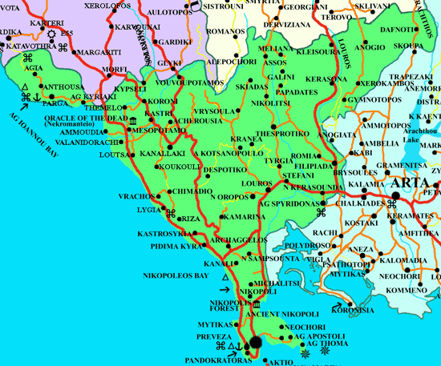

Accomodation Your accomodation will be held in one of the best hotels of Preveza city.
We will do our best to meet your expectation.
WELCOME IN PREVEZA CITY!
Open Seminar and Tournament Choi Jung Hwa 2013
Name of club:
Address:
Country:
Coach / Contact person:
Phone number: |  |  |  |  |  |  |  |  | Fax:
No | Name and Surname |  |  |  | Sex(M/F) |  |  | birth |  |  | Grade |  | Seminar | Tull | Sparring
1
2
3
4
5
6
7
8
9
10
11
12
13
14
15
16
17
18
19
20
21
22
23
24
25
26
27
28
29
30

Signature: | Please, send your entry forms until April 20, 2013.  E-mail: efkleasitf@yahoo.gr

