
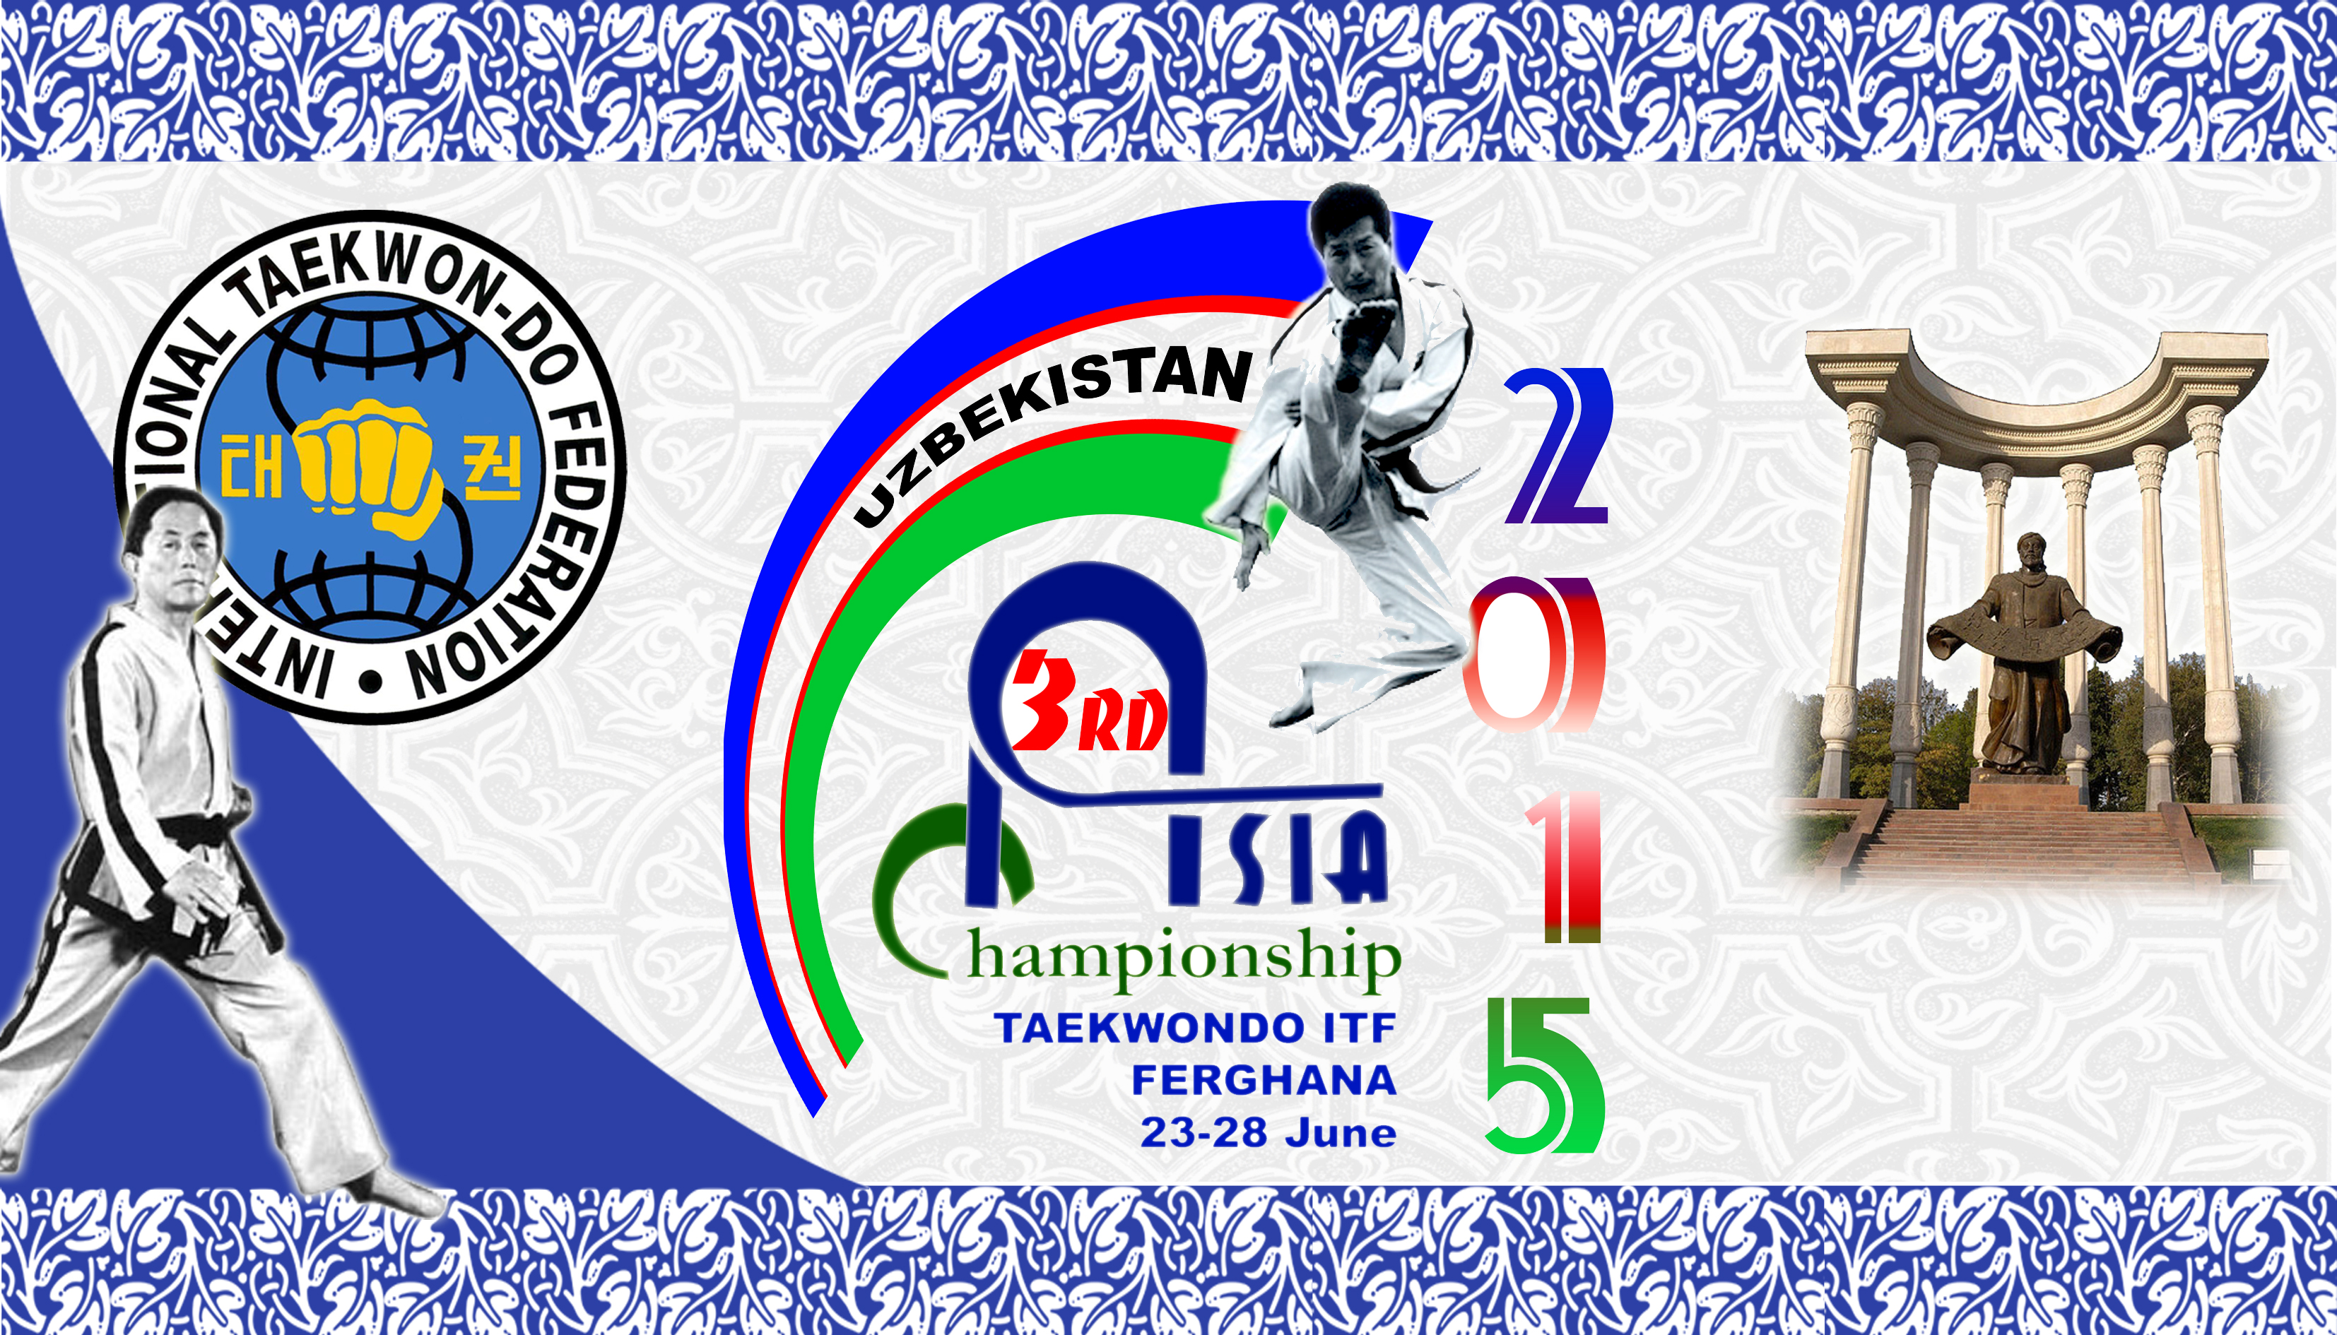
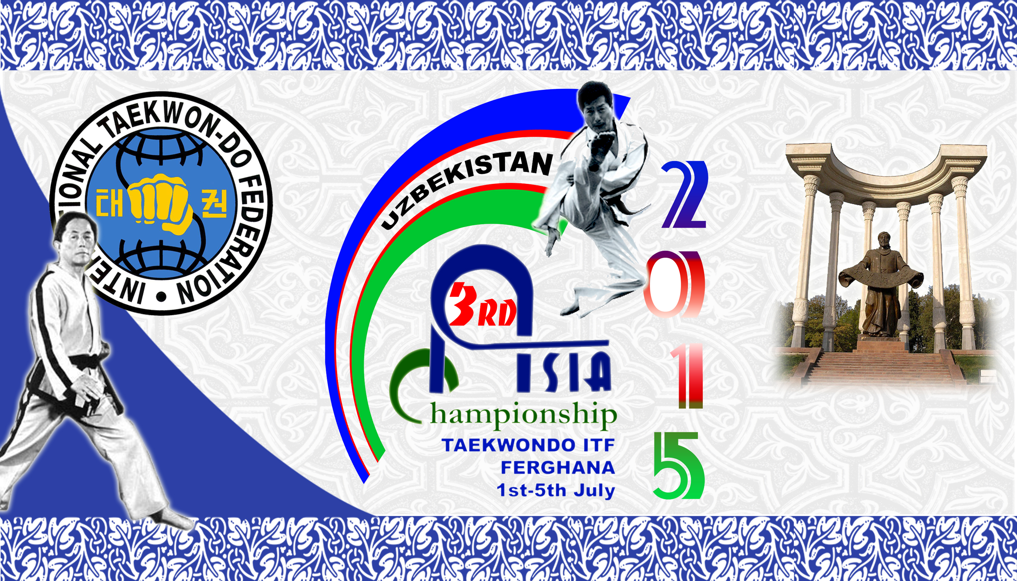

Even Date
1-5 July 2015
Event Venue Sport hall of Olimpic college of Ferghana.
Registration Date
1st July 2015
Registration Venue
Hotel Asia Ferghana
Official Accommodation Hotel Hotel Asia Ferghana
Club Hotel 777
Hotel Ziyorat
Application Form
Download www.itf-administration.com
Application Deadline
1st May 2015

Official Contact Detail :
Postal Address : No.150117, Ferghana City A.Yassaviy Street 52b-26 Uzbekiston.
Email : itfasiachamp@gmail.com
Email : Brat_uz@mail.ru
Cell Phone .: +99890-303-31-75

Traditional Taekwondo Federation
of Uzbekistan

3rd ITF Open Asia Taekwondo Championship, Uzbekistan, Fergana
Dear Masters, Instructors and Couches
It is with a great pleasure and pride that to invite you and your students to be my honorable guest in Uzbekistan, Fergana city from 1st - 5th July 2015 to participate in the 3rd ITF Asia Taekwondo Championships at Fergana.

The Championships is open to all ITF brother and sister. Children, Junior, Adult and Senior practitioners with 1st Degree Black Belt (and color belt) Holder or above are welcome to join the Pattern, Sparring, Power and Special Technique competition.

I am looking forward to see you all in Fergana, Uzbekistan. If you have any enquiry, please do not hesitate to contact our organizer - Mr. Bohodirov Botirjon on +99890 303 31 75 or email : brat_uz@mail.ru for more information.


Yours in Taekwon-Do,


Mr.Botirjon Bohodirov
Mr. Master Gayrat Kasimov (VII Dan) Chairman of organizing committee
President Traditional of 3rd Asia championship President
Taekwondo Federation of Uzbekistan Traditional Taekwondo Federation of Ferghana region
Even Date
1-5 July 2015
Event Venue Sport hall of Olimpic college of Ferghana.
Registration Date
1 July 2015
Registration Venue
Hotel Asia Ferghana
Official Accommodation Hotel Hotel Asia Ferghana
Club Hotel 777
Hotel Ziyorat
Application Form
Download www.itf-administration.com
Application Deadline
1st May 2015

Official Contact Detail :
Postal Address : No.150117, Ferghana City A.Yassaviy Street 52b-26 Uzbekiston.
Email : itfasiachamp@gmail.com
Email : Brat_uz@mail.ru
Cell Phone .: +99890-303-31-75

3rd ITF Open Asia

Taekwondo

Championships

Information Pack

The Event
The 3rd up Asia Taekwondo Championships will be held in 1st – 5th July
2015 in Fergana Uzbekistan.
The event open for all Taekwondo Practitioners:
- children (age 12 and below)
- Junior A (age 13-14)
- Junior B (age 15-17)
- Adult (age 18-35)
- Veteran (age above 35)
V

The Event Venue – Olympic sport college of Fergana
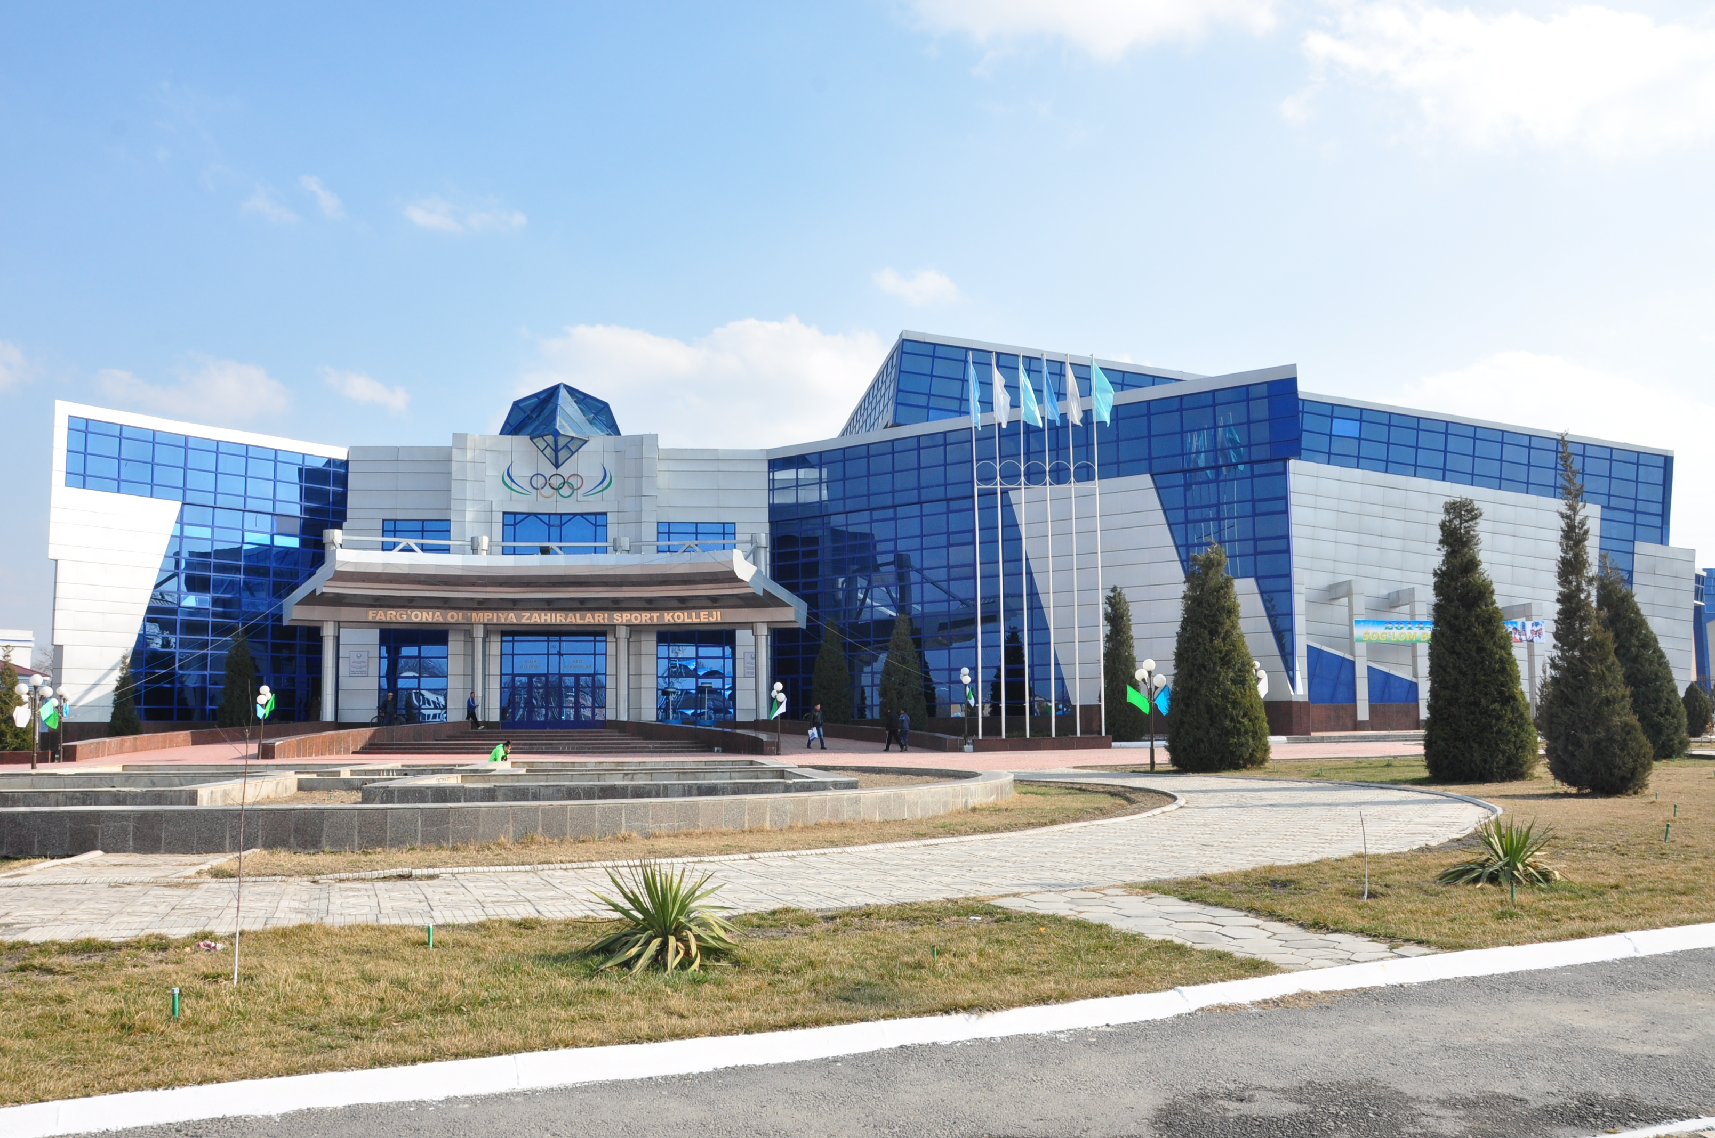
Olimpic Kollej is located at Center of Fergana city
The sport holds about 1500 spectators. And
it was held Tennis Challenger Cup,
Wrestling Asian Championships and etc.
The venue is about 5 km away from Fergana
International Airport and 1.5 km
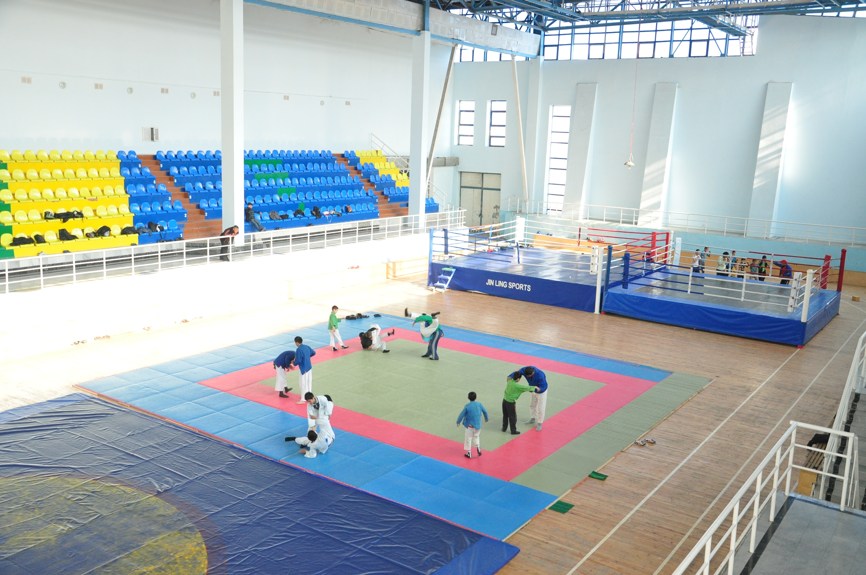
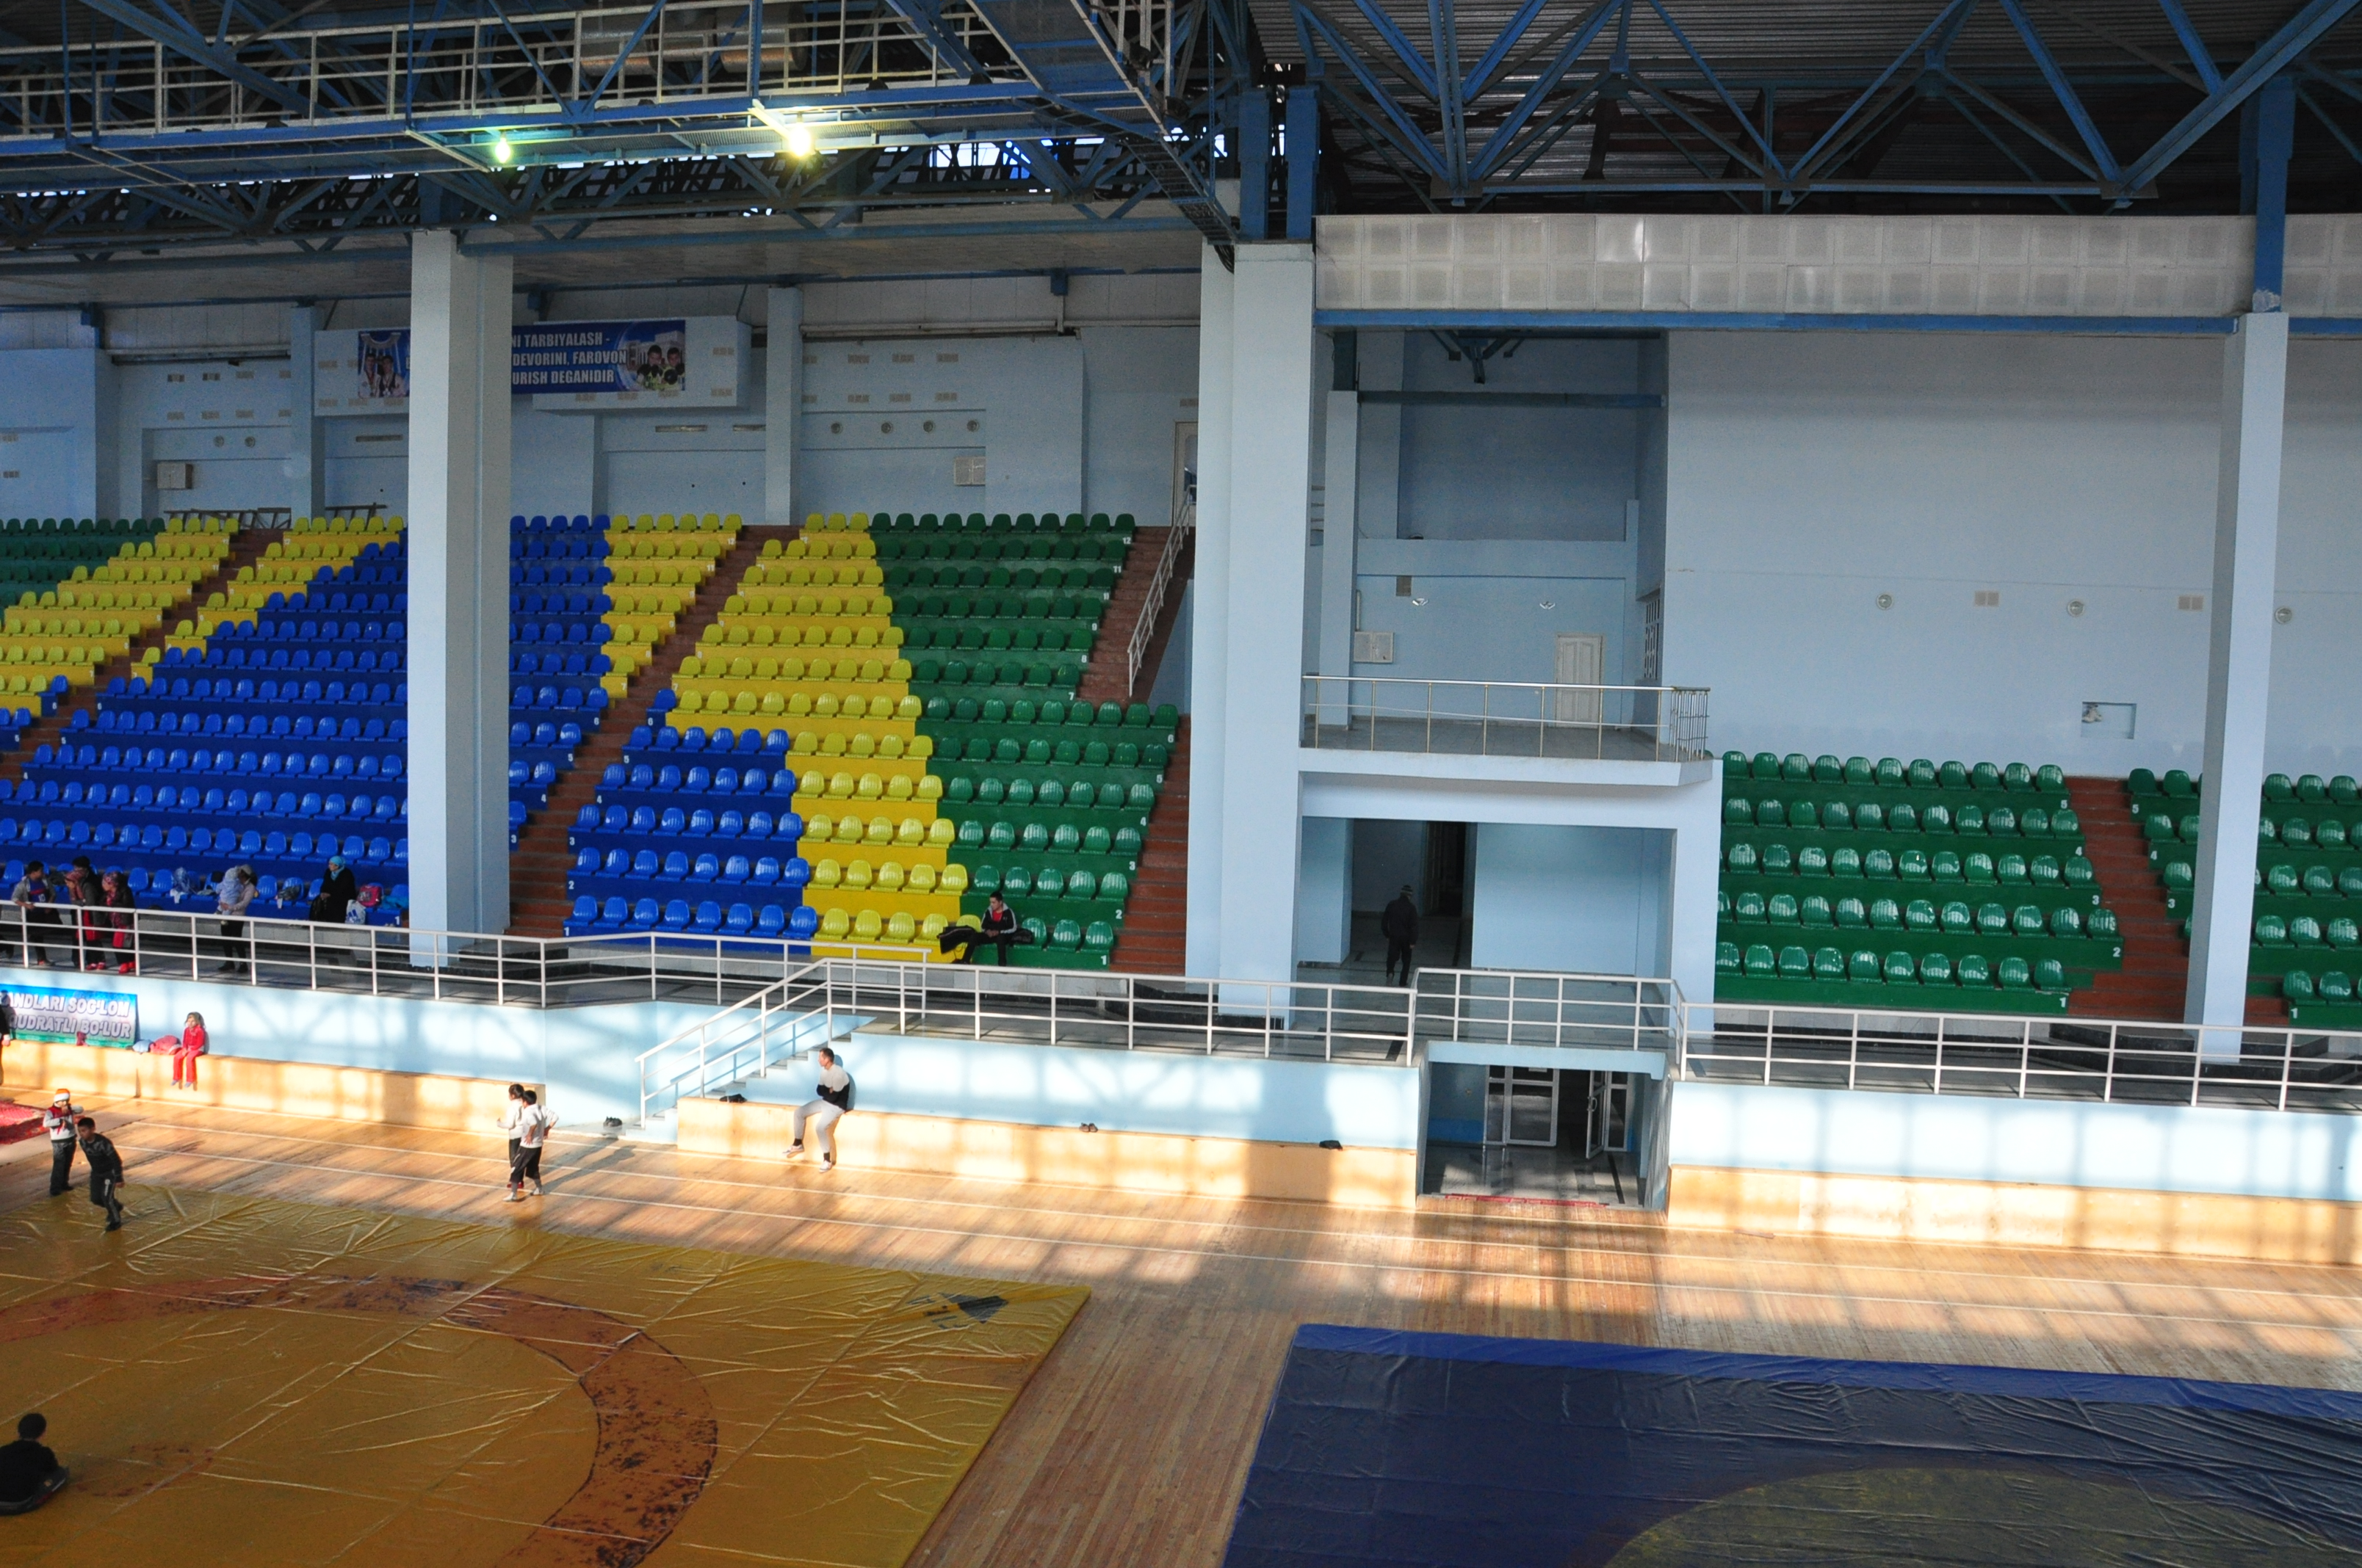
from the Official Accommodation hotel.

Even Date
1-5 July 2015
Event Venue Sport hall of Olimpic college of Ferghana.
Registration Date
1st July 2015
Registration Venue
Hotel Asia Ferghana
Official Accommodation Hotel Hotel Asia Ferghana
Club Hotel 777
Hotel Ziyorat
Application Form
Download www.itf-administration.com
Application Deadline
1st May 2015

Official Contact Detail :
Postal Address : No.150117, Ferghana City A.Yassaviy Street 52b-26 Uzbekiston.
Email : itfasiachamp@gmail.com
Email : Brat_uz@mail.ru
Cell Phone .: +99890-303-31-75

Traditional Taekwondo Federation
of Uzbekistan

Event Registration Venue
The event registration will be held on 1st July 2015, 9:00-20:00pm at Asia Hotel Fergana function room where is the official accommodation hotel for 3rd Asia Taekwondo-do Championships event.
For registration, please bring with your 1. Passport, 2. Competitor Registration Form with your recent photo, 3. Signed Medical Form, 4. Bank-in strip* for the 3rd Asia Championships event. Event Fee Structure: Participate entrance fee is $150 US for Junior A, Junior B, Adult and Veteran; Participate entrance fee is $100 US for Children Event(age under 12 years old); Coaches and Supporter fees are $70 US.
All above fee is covers the following items:
- ID card, entry to the competition venue
- *Competition days lunch
- Shutter bus to competition venue (Asia hotel and Ziyorat hotel only)
- Welcome Dinner
- Farewell party ($30 US, Optional)
All approved referees (Umpire) need to pay a minimum charge ($100 US) for the registration fee and will have provided accommodation, meals, transportation and welcome dinner.

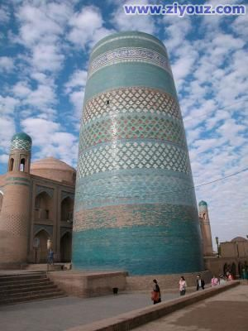
Even Date
1-5July 2015
Event Venue Sport hall of Olimpic college of Ferghana.
Registration Date
1July 2015
Registration Venue
Hotel Asia Ferghana
Official Accommodation Hotel Hotel Asia Ferghana
Club Hotel 777
Hotel Ziyorat
Application Form
Download www.itf-administration.com
Application Deadline
1st May 2015

Official Contact Detail :
Postal Address : No.150117, Ferghana City A.Yassaviy Street 52b-26 Uzbekiston.
Email : itfasiachamp@gmail.com
Email : Brat_uz@mail.ru
Cell Phone .: +99890-303-31-75

Traditional Taekwondo Federation
of Uzbekistan
Located in the city centre of Fergana, Hotel Asia Fergana features an outdoor swimming pool, a sauna, an on-site restaurant serving Asian and European cuisines, free Wi-Fi and free private parking.
The classically designed rooms here provide guests with a mini bar, a flat-screen TV, a seating area, air conditioning, and a private bathroom with a bath or shower.
Other property facilities include a 24-hour front desk, a bar, a garden, and a shuttle service.
The City Park and Fergana City Hall are both a 5 to 10-minute walk away.
Hotel Asia Fergana is 4.5 km from Fergana International Airport.

Asia Hotel Ferghana (Registration & Weight-in venue)

Street Navoiy 26, 100115

Ferghana
Type of room: Deluxe (single/twin)

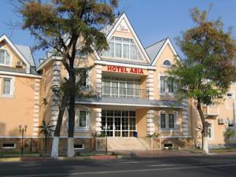

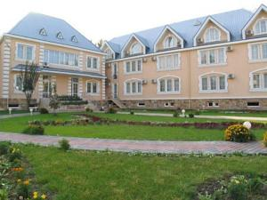

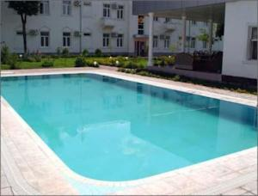
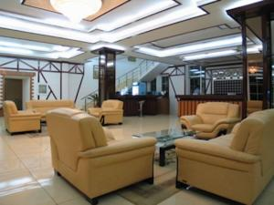
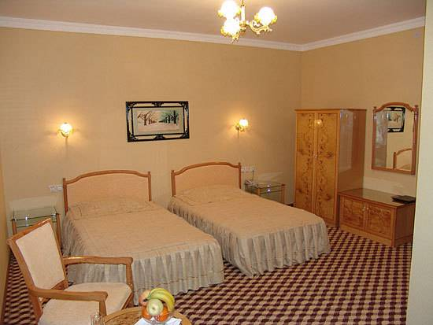
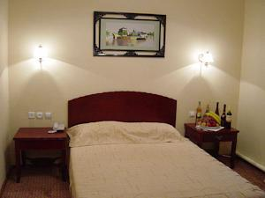
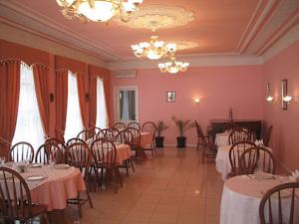

Even Date
1-5July 2015
Event Venue Sport hall of Olimpic college of Ferghana.
Registration Date
1 July 2015
Registration Venue
Hotel Asia Ferghana
Official Accommodation Hotel Hotel Asia Ferghana
Club Hotel 777
Hotel Ziyorat
Application Form
Download www.itf-administration.com
Application Deadline
1st May 2015

Official Contact Detail :
Postal Address : No.150117, Ferghana City A.Yassaviy Street 52b-26 Uzbekiston.
Email : itfasiachamp@gmail.com
Email : Brat_uz@mail.ru
Cell Phone .: +99890-303-31-75

Traditional Taekwondo Federation
of Uzbekistan

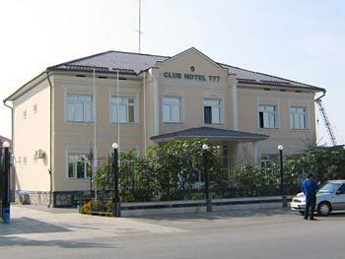
Other Accommodation Place
Club Hotel 777 Fergana, Uzbekistan
7a Pushkin Str - Fergana, Fergana, Uzbekistan
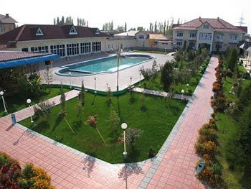
Standard amenities for all rooms include: - All room is included daily breakfast
- Fully-equipped kitchen
- Washing machine and dryer (in selected units)
- Broadband Internet service
- LCD TV with satellite TV programmers
- Home entertainment system with DVD player
- Bedside radio
- Telephone with IDD/DID & Voicemail facilities
- Personal safe
- iron and ironing board

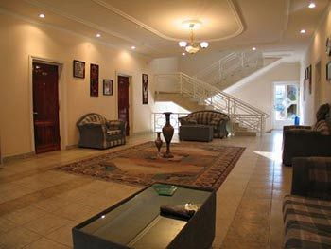
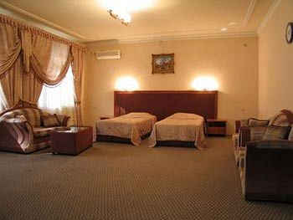
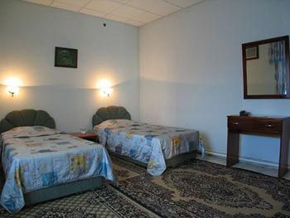
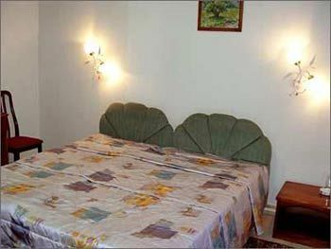
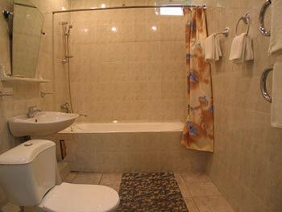

Even Date
1-5 July 2015
Event Venue Sport hall of Olimpic college of Ferghana.
Registration Date
1 July 2015
Registration Venue
Hotel Asia Ferghana
Official Accommodation Hotel Hotel Asia Ferghana
Club Hotel 777
Hotel Ziyorat
Application Form
Download www.itf-administration.com
Application Deadline
1st May 2015

Official Contact Detail :
Postal Address : No.150117, Ferghana City A.Yassaviy Street 52b-26 Uzbekiston.
Email : itfasiachamp@gmail.com
Email : Brat_uz@mail.ru
Cell Phone .: +99890-303-31-75

Traditional Taekwondo Federation
of Uzbekistan
Participant (Junior A, Junior B, Adult and Veteran) Booking Package:
Club Hotel 777 Fergana, Uzbekistan
*Remark: All Rate in USD ($)
Period of Accommodation | 1st - 5th July’15 (5 nights) | 1st - 5th July’15 (5 nights )
Package Code | Share Room - Twin | One Room - King
Package Code | Price Per Pax
A1 | $480 (early bird) $500
A2 |  | $520 (early bird) $600
Period of Accommodation | 1st - 6th July’15 (6 nights) | 1st - 6th July’15 (6 nights))
Package Code | Share Room - Twin | One Room - King
Package Code | Price Per Pax
A3 | $580 (early bird) $600
A4 |  | $650 (early bird) $700
*Package include: ID card, Entry to the competition venue, 3 competition days lunch, 5 competition days breakfast and dinner, shutter bus to competition venue, Welcome Dinner, Accommodation & 2 way Airport Transport from Fergana airport
Early bird rate are valid for payment before or on 1st April 2015.
Please made your payment before or on 1th May 2015.

Even Date
1-5 July 2015
Event Venue Sport hall of Olimpic college of Ferghana.
Registration Date
1 st July 2015
Registration Venue
Hotel Asia Ferghana
Official Accommodation Hotel Hotel Asia Ferghana
Club Hotel 777
Hotel Ziyorat
Application Form
Download www.itf-administration.com
Application Deadline
1st May 2015

Official Contact Detail :
Postal Address : No.150117, Ferghana City A.Yassaviy Street 52b-26 Uzbekiston.
Email : itfasiachamp@gmail.com
Email : Brat_uz@mail.ru
Cell Phone .: +99890-303-31-75

Traditional Taekwondo Federation

of Uzbekistan

Participant (Junior A, Junior B, Adult and Veteran) Booking Package:

Asia Hotel Fergana, Uzbekistan
*Remark: All Rate in USD ($)
Period of Accommodation | 1st- 5th July’15 (5 nights) | 1st- 5th July’15 (5 nights )
Package Code | Share Room - Twin | One Room - King
Package Code | Price Per Pax
B1 | $480 (early bird) $500
B2 |  | $520 (early bird) $600
Period of Accommodation | 1st - 6th July’15 (6 nights) | 1st - 6th July’15 (6 nights)
Package Code | Share Room - Twin | One Room - King
Package Code | Price Per Pax
B3 | $580 (early bird) $600
B4 |  | $650 (early bird) $700
*Package include: ID card, Entry to the competition venue, 3 competition days lunch, 5 competition days breakfast and dinner, shutter bus to competition venue, Welcome Dinner, Accommodation & 2 way Airport Transport from Fergana airport.
Early bird rate are valid for payment before or on 1st April 2015.
Please made your payment before or on 1th May 2015.

Even Date
1-5 July2015
Event Venue Sport hall of Olimpic college of Ferghana.
Registration Date
1st luly 2015
Registration Venue
Hotel Asia Ferghana
Official Accommodation Hotel Hotel Asia Ferghana
Club Hotel 777
Hotel Ziyorat
Application Form
Download www.itf-administration.com
Application Deadline
1st May 2015

Official Contact Detail :
Postal Address : No.150117, Ferghana City A.Yassaviy Street 52b-26 Uzbekiston.
Email : itfasiachamp@gmail.com
Email : Brat_uz@mail.ru
Cell Phone .: +99890-303-31-75

Traditional Taekwondo Federation

of Uzbekistan

Participant (Children age under 12 years old) Booking Package:
Club Hotel 777 Fergana, Uzbekistan

Remark: All Rate in USD ($)
Period of Accommodation | 1st- 5th July’15 (5 nights)) | 1st- 5th July’15 (5 nights)
Package Code | Share Room - Twin | One Room - King
Package Code | Price Per Pax
C1 | $450 (early bird) $430
C2 |  | $520 (early bird) $550
Period of Accommodation | 1st - 6th July’15 (6 nights)) | 1st - 6th July’15 (6 nights))
Package Code | Share Room - Twin | One Room - King
Package Code | Price Per Pax
C3 | $500 (early bird) $530
C4 |  | $600 (early bird) $630
*Package include: ID card, Entry to the competition venue, 3 competition days lunch, 5 competition days breakfast and dinner, shutter bus to competition venue, Welcome Dinner, Accommodation & 2 way Airport Transport from Fergana airport.
Early bird rate are valid for payment before or on 1st April 2015. Please made your payment before or on 1th May 2015.

Even Date
1-5 July 2015
Event Venue Sport hall of Olimpic college of Ferghana.
Registration Date
1st July 2015
Registration Venue
Hotel Asia Ferghana
Official Accommodation Hotel Hotel Asia Ferghana
Club Hotel 777
Hotel Ziyorat
Application Form
Download www.itf-administration.com
Application Deadline
1st May 2015

Official Contact Detail :
Postal Address : No.150117, Ferghana City A.Yassaviy Street 52b-26 Uzbekiston.
Email : itfasiachamp@gmail.com
Email : Brat_uz@mail.ru
Cell Phone .: +99890-303-31-75

Traditional Taekwondo Federation

of Uzbekistan

Participant (Children age under 12 years old) Booking Package:

Asia Hotel Fergana, Uzbekistan
*Remark: All Rate in USD ($)
Period of Accommodation | 1st- 5th July’15 (5 nights) | 1st- 5th July’15 (5 nights)
Package Code | Share Room - Twin | One Room - King
Package Code | Price Per Pax
D1 | $450 (early bird) $430
D2 |  | $520 (early bird) $550
Period of Accommodation | 1st - 6th July’15 (6 nights) | 1st - 6th July’15 (6 nights)
Package Code | Share Room - Twin | One Room - King
Package Code | Price Per Pax
D3 | $500 (early bird) $530
D4 |  | $600 (early bird) $630
*Package include: ID card, Entry to the competition venue, 3 competition days lunch, 5 competition days breakfast and dinner, shutter bus to competition venue, Welcome Dinner, Accommodation & 2 way Airport Transport. from Fergana airport

Early bird rate are valid for payment before or on 1st April 2015. Please made your payment before or on 1th May 2015.

Even Date
1-5July 2015
Event Venue Sport hall of Olimpic college of Ferghana.
Registration Date
1st July 2015
Registration Venue
Hotel Asia Ferghana
Official Accommodation Hotel Hotel Asia Ferghana
Club Hotel 777
Hotel Ziyorat
Application Form
Download www.itf-administration.com
Application Deadline
1st May 2015

Official Contact Detail :
Postal Address : No.150117, Ferghana City A.Yassaviy Street 52b-26 Uzbekiston.
Email : itfasiachamp@gmail.com
Email : Brat_uz@mail.ru
Cell Phone .: +99890-303-31-75

Traditional Taekwondo Federation

of Uzbekistan

Participant (Junior A, Junior B, Adult and Veteran) Booking Package:

Ziyorat Hotel Fergana, Uzbekistan
*Remark: All Rate in USD ($)
Period of Accommodation | 1st- 5th July’15 (5 nights) | 1st- 5th July’15 (5 nights)
Package Code | Share Room - Twin | One Room - King
Package Code | Price Per Pax
E1 | $480 (early bird) $500
E2 |  | $520 (early bird) $600
Period of Accommodation | 1st - 6th July’15 (6 nights) | 1st - 6th July’15 (6 nights)
Package Code | Share Room - Twin | One Room - King
Package Code | Price Per Pax
E3 | $580 (early bird) $600
E4 |  | $650 (early bird) $700
*Package include: ID card, Entry to the competition venue, 3 competition days lunch, 5 competition days breakfast and dinner, shutter bus to competition venue, Welcome Dinner, Accommodation & 2 way Airport Transport from Fergana airport.
Early bird rate are valid for payment before or on 1st April 2015.

Please made your payment before or on 1th May 2015.

Even Date
1-5 July 2015
Event Venue Sport hall of Olimpic college of Ferghana.
Registration Date
1sth July 2015
Registration Venue
Hotel Asia Ferghana
Official Accommodation Hotel Hotel Asia Ferghana
Club Hotel 777
Hotel Ziyorat
Application Form
Download www.itf-administration.com
Application Deadline
1st May 2015

Official Contact Detail :
Postal Address : No.150117, Ferghana City A.Yassaviy Street 52b-26 Uzbekiston.
Email : itfasiachamp@gmail.com
Email : Brat_uz@mail.ru
Cell Phone .: +99890-303-31-75

Traditional Taekwondo Federation

of Uzbekistan

Coach/ Manager/ Supporter Booking Package:

Asia Hotel Fergana, Uzbekistan
*Remark: All Rate in USD ($)
Period of Accommodation | 1st- 5th July’15 (5 nights) | 1st- 5th July’15 (5 nights)
Package Code | Share Room - Twin | One Room - King
Package Code | Price Per Pax
F1 | $390 (early bird) $420
F2 |  | $670 (early bird) $700
Period of Accommodation | 1st - 6th July’15 (6 nights) | 1st - 6th July’15 (6 nights))
Package Code | Share Room - Twin | One Room - King
Package Code | Price Per Pax
F3 | $460 (early bird) $490
F4 |  | $810 (early bird) $840
*Package include: ID card, Entry to the competition venue, 3 competition days lunch, shutter bus to competition venue, Welcome Dinner, Accommodation & 2 way Airport Transport from Fergana Airport.
Early bird rate are valid for payment before or on 1st April 2015.
Please made your payment before or on 1th May 2015.

Even Date
1-5July 2015
Event Venue Sport hall of Olimpic college of Ferghana.
Registration Date
1st July 2015
Registration Venue
Hotel Asia Ferghana
Official Accommodation Hotel Hotel Asia Ferghana
Club Hotel 777
Hotel Ziyorat
Application Form
Download www.itf-administration.com
Application Deadline
1st May 2015

Official Contact Detail :
Postal Address : No.150117, Ferghana City A.Yassaviy Street 52b-26 Uzbekiston.
Email : itfasiachamp@gmail.com
Email : Brat_uz@mail.ru
Cell Phone .: +99890-303-31-75

Master Booking Package:

Asia Hotel Fergana, Uzbekistan
*Remark: All Rate in USD ($)
Period of Accommodation | 1st- 5th July’15 (5 nights) | Period of Accommodation | 1st - 6th July’15 (6 nights)
Package Code | One Room - King | Package | One Room - King
Package Code | Price Per Pax | Package | Price Per Pax
Ml | $350 (early bird) $380 | M2 | $410 (early bird) $440

*Package include: ID card, Entry to the competition venue, 3 competition days lunch, 5 competition days breakfast and dinner, In-town transport, Welcome Dinner, Farewell Party, Accommodation & 2 way Airport Transport from Fergana airport
Early bird rate are valid for payment before or on 1st April 2015. Please made your payment before or on 1-May 2015.

Even Date
1-5July 2015
Event Venue Sport hall of Olimpic college of Ferghana.
Registration Date
1st July 2015
Registration Venue
Hotel Asia Ferghana
Official Accommodation Hotel Hotel Asia Ferghana
Club Hotel 777
Hotel Ziyorat
Application Form
Download www.itf-administration.com
Application Deadline
1st May 2015

Official Contact Detail :
Postal Address : No.150117, Ferghana City A.Yassaviy Street 52b-26 Uzbekiston.
Email : itfasiachamp@gmail.com
Email : Brat_uz@mail.ru
Cell Phone .: +99890-303-31-75

Traditional Taekwondo Federation

of Uzbekistan

Transportation
The Organizing Committee will assist with transportation from Tashkent and Fergana International Airport (TAS) (FER)to Competitor's accommodation places when you arrives accommodation detail in the Delegation Information Form for our arrangement.
Shuttle bus service will be provided between Asia Hotel and Ziyorat Hotel to the 3rd Asia Taekwondo Championships event locations – Sport hall of Olympic college and city Art center during the event period (1st - 5th July 2015) at 08:30 in the morning.

Welcome Dinner and Farewell Party
Welcome Dinner will be held on 1stor 2 July 2015 night.
- All Participants fees is included Welcome dinner only
- Formal Dress should be required
Farewell Party (Optional) will be held on 5th July 2015 night with the charging of USD30

Personal Health Insurance
It is the participating individual's responsibility to arrange their own personal health insurance. Evidence of this insurance must be made available upon request. The Organizing Committee assumes no responsibility for any injury or loss incurred as a result of attendance or participation in the event.

Visa Requirement by Country
Country that require Visa:
Please check the link as below.
http://www.mfa.uz/ru/consular/visa/
Please be informed that the representatives of the International Taekwondo Federations would not be responsible for your visa application other than providing an invitation letter of the concerning event.

Even Date
1-5July2015
Event Venue Sport hall of Olimpic college of Ferghana.
Registration Date
1 July 2015
Registration Venue
Hotel Asia Ferghana
Official Accommodation Hotel Hotel Asia Ferghana
Club Hotel 777
Hotel Ziyorat
Application Form
Download www.itf-administration.com
Application Deadline
1st May 2015

Official Contact Detail :
Postal Address : No.150117, Ferghana City A.Yassaviy Street 52b-26 Uzbekiston.
Email : itfasiachamp@gmail.com
Email : Brat_uz@mail.ru
Cell Phone .: +99890-303-31-75

Traditional Taekwondo Federation
of Uzbekistan

Event Schedule (Predicted)
Day 01 (2/07/2015)
- Open Ceremony
- All Children pattern and sparring event
- All Junior A and B individual Pattern event
- All Team Pattern event (junior, adult)
- Welcome dinner
Day 02(3/07/2015)
- All Adult Individual Pattern
- All Junior A and B individual Sparring
- All Special Technique

Day 03 (4/07/2015)
- All Adult Individual Sparring
- All Veteran Individual Sparring
- All Team Sparring

Day 04 (5/07/2015)
- All finally sparring
- All Team finally sparring
- Closing ceremony
- Farewell Party

2. Bukhara, Samarkand and Hiva Tour (Day Tour : USD250)
** Transport Return ** Visiting 10 place , take 36-40 hours ** Lunch (meal)

Extra Activities: Uzbekistan Short Trip: Fergana and Tashkent tour (Day Tour : USD100)
** Transport Return – Kokand old city
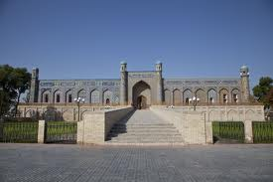
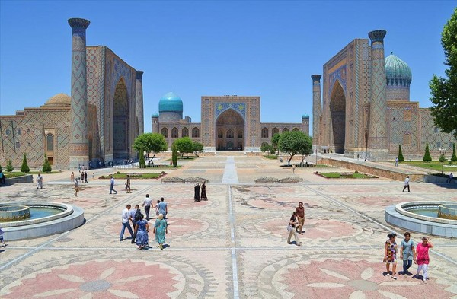

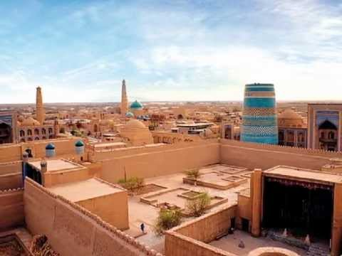
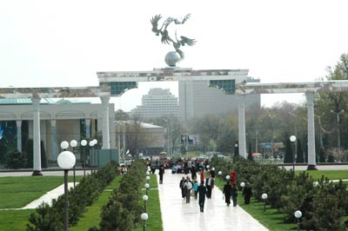

Xiva Tashkent Bukhara




