Dear Masters, instructors and students,

It is great pleasure for us to invite you to take part in Master Class on Saturday the 22nd of September 2012 organized by our Czech Association at the twentieth Anniversary of our Taekwon-Do School.

This Master Class will be lead by the son of Taekwon-Do Founder General Choi Hong Hi,
Grand Master Choi Jung Hwa IX. Dan, President of the ITF

Participation: -Degree holders
-Participation is open

Seminar information:
Date: 22-th of September 2012
Location: Sport Hall F. J. Curie 3302/5, 669 02 Znojmo, Czech Republic Access plan: http://www.mapy.cz/#st=s@sss=1@ssq=id%3Apremise%20687367
Time: from 09:45 till 17:00 (09:30 gathering in the Dojang, lunch break - sandwich/snack with assorted drinks on place)
Cost: € 100,00

Please complete enclosed application form and send it to: secretary@itf-czech.cz
Hotel reservations to be booked personally – see details on following page.
(Please book your accommodation on time due to limited capacity on this weekend)

Deadline for your applications and payment is the 17-th August 2012.
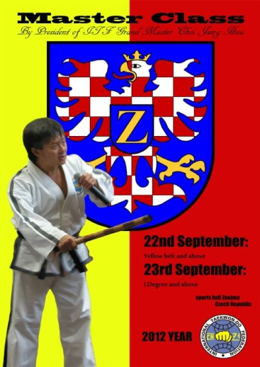

Payment:
€ 100,00 bank transfer to Raiffeisenbank Znojmo, Czech republic
Account Number: 5107396001/5500 IBAN: CZ7155000000005107396001

Accommodation:
Hotel Dukla Znojmo, Holandská 3283/30, 671 81 Znojmo, Czech Republic
www.hotel-dukla.cz e-mail: blazicek@hotel-dukla.cz
Hotel Prestige****, Pražská 100, 669 02 Znojmo, Czech Republic
www.hotel-prestige.cz e-mail: recepce@hotel-prestige.cz
Penziony Grant GT, www.ubytovani-znojmo.biz

Hotel reservations to be booked personally. (Please book your accommodation on time due to limited capacity on this weekend)
Click here for information about Train transfer from Vienna Airport to Znojmo.

We look forward to seeing you in Znojmo in September.
With kind regards,

František Macek IV. Dan,
President of Czech Taekwon-Do Association

APPLICATION FORM
(Application is only complete when the costs of € 100,00 is transferred to the bank account)

Name | School/Club | Degree

